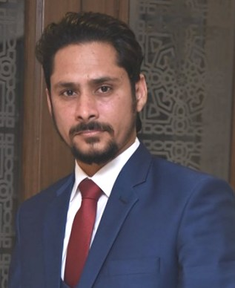

BILAL AHMED

OBJECTIVE

To use my skills and potential to assist an organization in achieving its goals which seeking long term career with optimum growth. This objective would be supported by my qualification, in addition to the management experience and multi-lingual command.

EDUCATION:

CONTACT

|  |  |
| --- | --- |
| **2010**  **0331-5195278** | **FEDERAL URDU UNIVERSITY, ISLAMABAD**  **M.B.A**(Finance) |
| **2007**  **House # 4112, Street . #11,** **Gulzar-e-Quaid, Rawalpindi** | **A.I.O.U, ISLAMABAD**  **B.Sc** (Business Math, State & Economics) |

EXPERIENCE:

**fasst.sallar@gmail.com**

|  |
| --- |
| **GLITZ Pharma**, Sarran Rawalpindi (2014-2018)  COMPUTER SKILLS  I have functional knowledge of:   * MS Word, MS Excel & PowerPoint * Internet Browsing & Email * Quick book & Peachtree, Orbit System   Worked as ***Finance Officer***   * + - * Prepare journal entries   PERSONAL DETAILS  Father's Name: Muhammad Ahmed  Date of Birth: 11th September 1984  CNIC No: 37302-2577678-1  Nationality: Pakistani       * + - * Complete general ledger operations       * Monthly closings and preparation of monthly financial statements       * Reconcile and maintain balance sheet accounts       * Draw up monthly financial reports       * Prepare analysis of accounts as requested       * Assist with year end closings       * Administer accounts receivable and accounts payable       * Prepare tax computations and returns       * Assist in preparing budgets and forecasts       * Assist with payroll administration       * Monitor and resolve bank issues including fee anomalies and check differences       * Account/Bank reconciliations       * Review and process expense reports       * Assist with preparation and coordination of the audit process       * Assist with implementing and maintaining internal financial controls and procedures.   Worked as ***Costing Officer***  Responsibilities:  PERSONAL SKILLS   * Team Player * Leadership Skills * Decision Maker * Communication Skills   + - * In process, yield completed **BMR** status check and reported to MD       * Closed **BMR Audit,** reported to MD and QA department       * Due to Pending **supplier invoices** Actualcurrent payable noted and reported to MD       * **GRN** status report on daily basis and reported to MD       * FGS department **Audit** twice in a month and mention non moving items from FGS       * RMS department **Audit** twice in a month and mention non moving items from RMS   LANGUAGES   * + - * Cross check daily production target and reported to MD       * **Delivery challan** cross check twice in a week * **English** * **Urdu** * **Punjabi**   **Shifa International Hospital,** Islamabad (2011)  Worked as **Internee** in Finance and Audit Department  **Akbar & Zia Pvt. Ltd,** Islamabad (2012)  Worked as Internee in Account Departments |